Jan/Feb program descriptions

### Special events:

**Tu Bishvat seder (Leslie create flyer)**

Date: January 28th at 7:30

Celebrate the birthday of the trees with a special ceremony complete with ritual foods, learning, and four glasses of wine! We’ll tell you what foods and booze to prepare at home and lead you through some learning about the spiritual meaning of different fruits and seasons. We’ll also celebrate the trees by learning about issues that affect the environment and how we can help reduce the impact.

Things to prepare at home for this seder (please prepare at least one from each category, but you can have as many from each category as you like!):

* Wine or grape juice, both red and white
* Bread or wheat crackers
* First fruit: Something with an inedible peel but edible inside, like citrus (orange or grapefruit), or nuts (Almonds, pecans or walnuts)
* Second fruit: Something with an edible outside but a hard center: olives, dates or avocado
* Third fruit: something edible throughout, like figs, grapes, or berries (strawberries, blueberries or blackberries)
* Fourth fruit: a fragrant herb like mint or dill

We will be using this haggadah, which you can print in advance if you like:

<http://hazon.org/wp-content/uploads/2011/06/Haggadah.pdf>

**Learning to Cope with COVID life: Special Sessions with Jewish Family Services (Leslie create flyer)**

Date: February 4th at 8:30pm and February 11th at 7:30

As the COVID 19 pandemic stretches on, many of us are feeling the strain of isolation and the stresses of pandemic life. Jewish Family Services will guide us through some strategies to cope with COVID and isolation in two separate sessions. On February 11th at 7:30pm Marjorie Koch we will talk about coping strategies for older adults. Marjorie is an Outpatient Therapist, with a specialty in working with adults and seniors.

On February 4th at 8:30pm we will have a session for parents of young children on helping children cope with pandemic life. Mary Tarbell, who is a Licensed Professional Counselor and a Registered Play Therapist, will lead that discussion. We hope these sessions will help you and your family find comfort and strength in this difficult time.

**The Arc of Justice: A Martin Luther King Junior Day panel (Leslie create flyer)**

**Note for Leslie: I really like the way** [**this flyer**](https://www.facebook.com/fentster/photos/gm.381565549733512/1689538471247879/?type=3&theater) **put different pictures of faces in this octagonal honey-comb shape if you know how to do that...**

Date: January 18th 7pm (advertise to community)

“Life’s most persistent and urgent question is, ‘What are you doing for others?’”

~Martin Luther King Jr.

Dr. Martin Luther King Jr. famously said, “the arc of the moral universe is long, but it bends toward justice.” Dr. King was a leader in a movement for racial and economic justice, but the work did not end with him. Social justice leaders today continue to seek equality, working to solve problems caused by systemic oppression. Beth El will commemorate the life and legacy of Reverend Dr. Martin Luther King Jr. with a panel of some of Harrisburg’s key black leaders and state representative Patty Kim, who will discuss the issues their communities face. Each leader will speak about what their organization is doing to address these problems, and how we in the Jewish community can be their allies.

Speaker titles and pictures:

1. Patty Kim- Pennsylvania State representative and former Harrisburg City Councilwoman
2. Danielle Bowers- Harrisburg City Councilwoman and MLK Institute Scholar
3. Reverend Earl Harris- President of the Interdenominational Ministers Conference of Greater Harrisburg, Former Pastor of St. Paul Missionary Baptist Church and founder of Earl Harris Ministries
4. Lavelle Mohammed Executive Director and Principal of The Nativity School, a non-denominational, faith-based preparatory middle school aiming to break the cycle of poverty for low-income, inner-city boys
5. Floyd Stokes- Founder and Executive Director of the American Literacy Corporation (ALC), and of the African American Memorial Fund. Author of over 20 children’s books.
6. Winnie Okello- Creator of the Harassment and Assault Reporting Platform (H.A.R.P), leader in Greater Harrisburg Young Professionals of Color
7. Lamont Jones: community activist, motivational speaker, entrepreneur, certified life coach, and MLK Institute Scholar

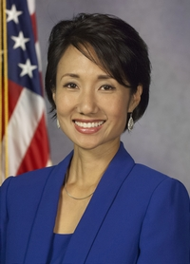Patty Kim

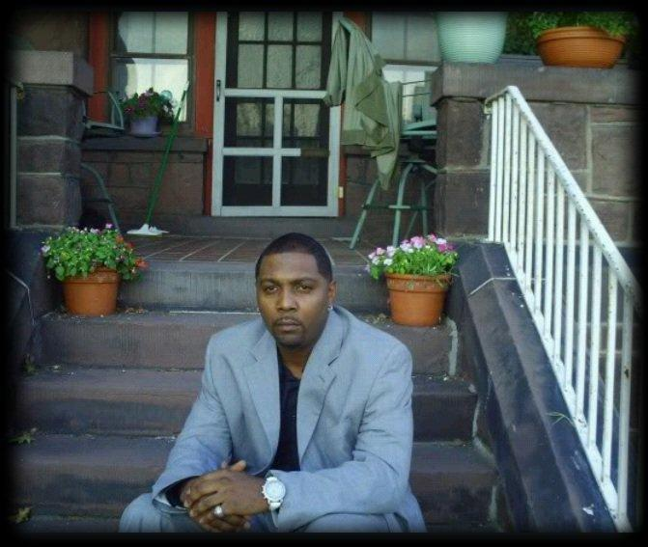Lamont Jones

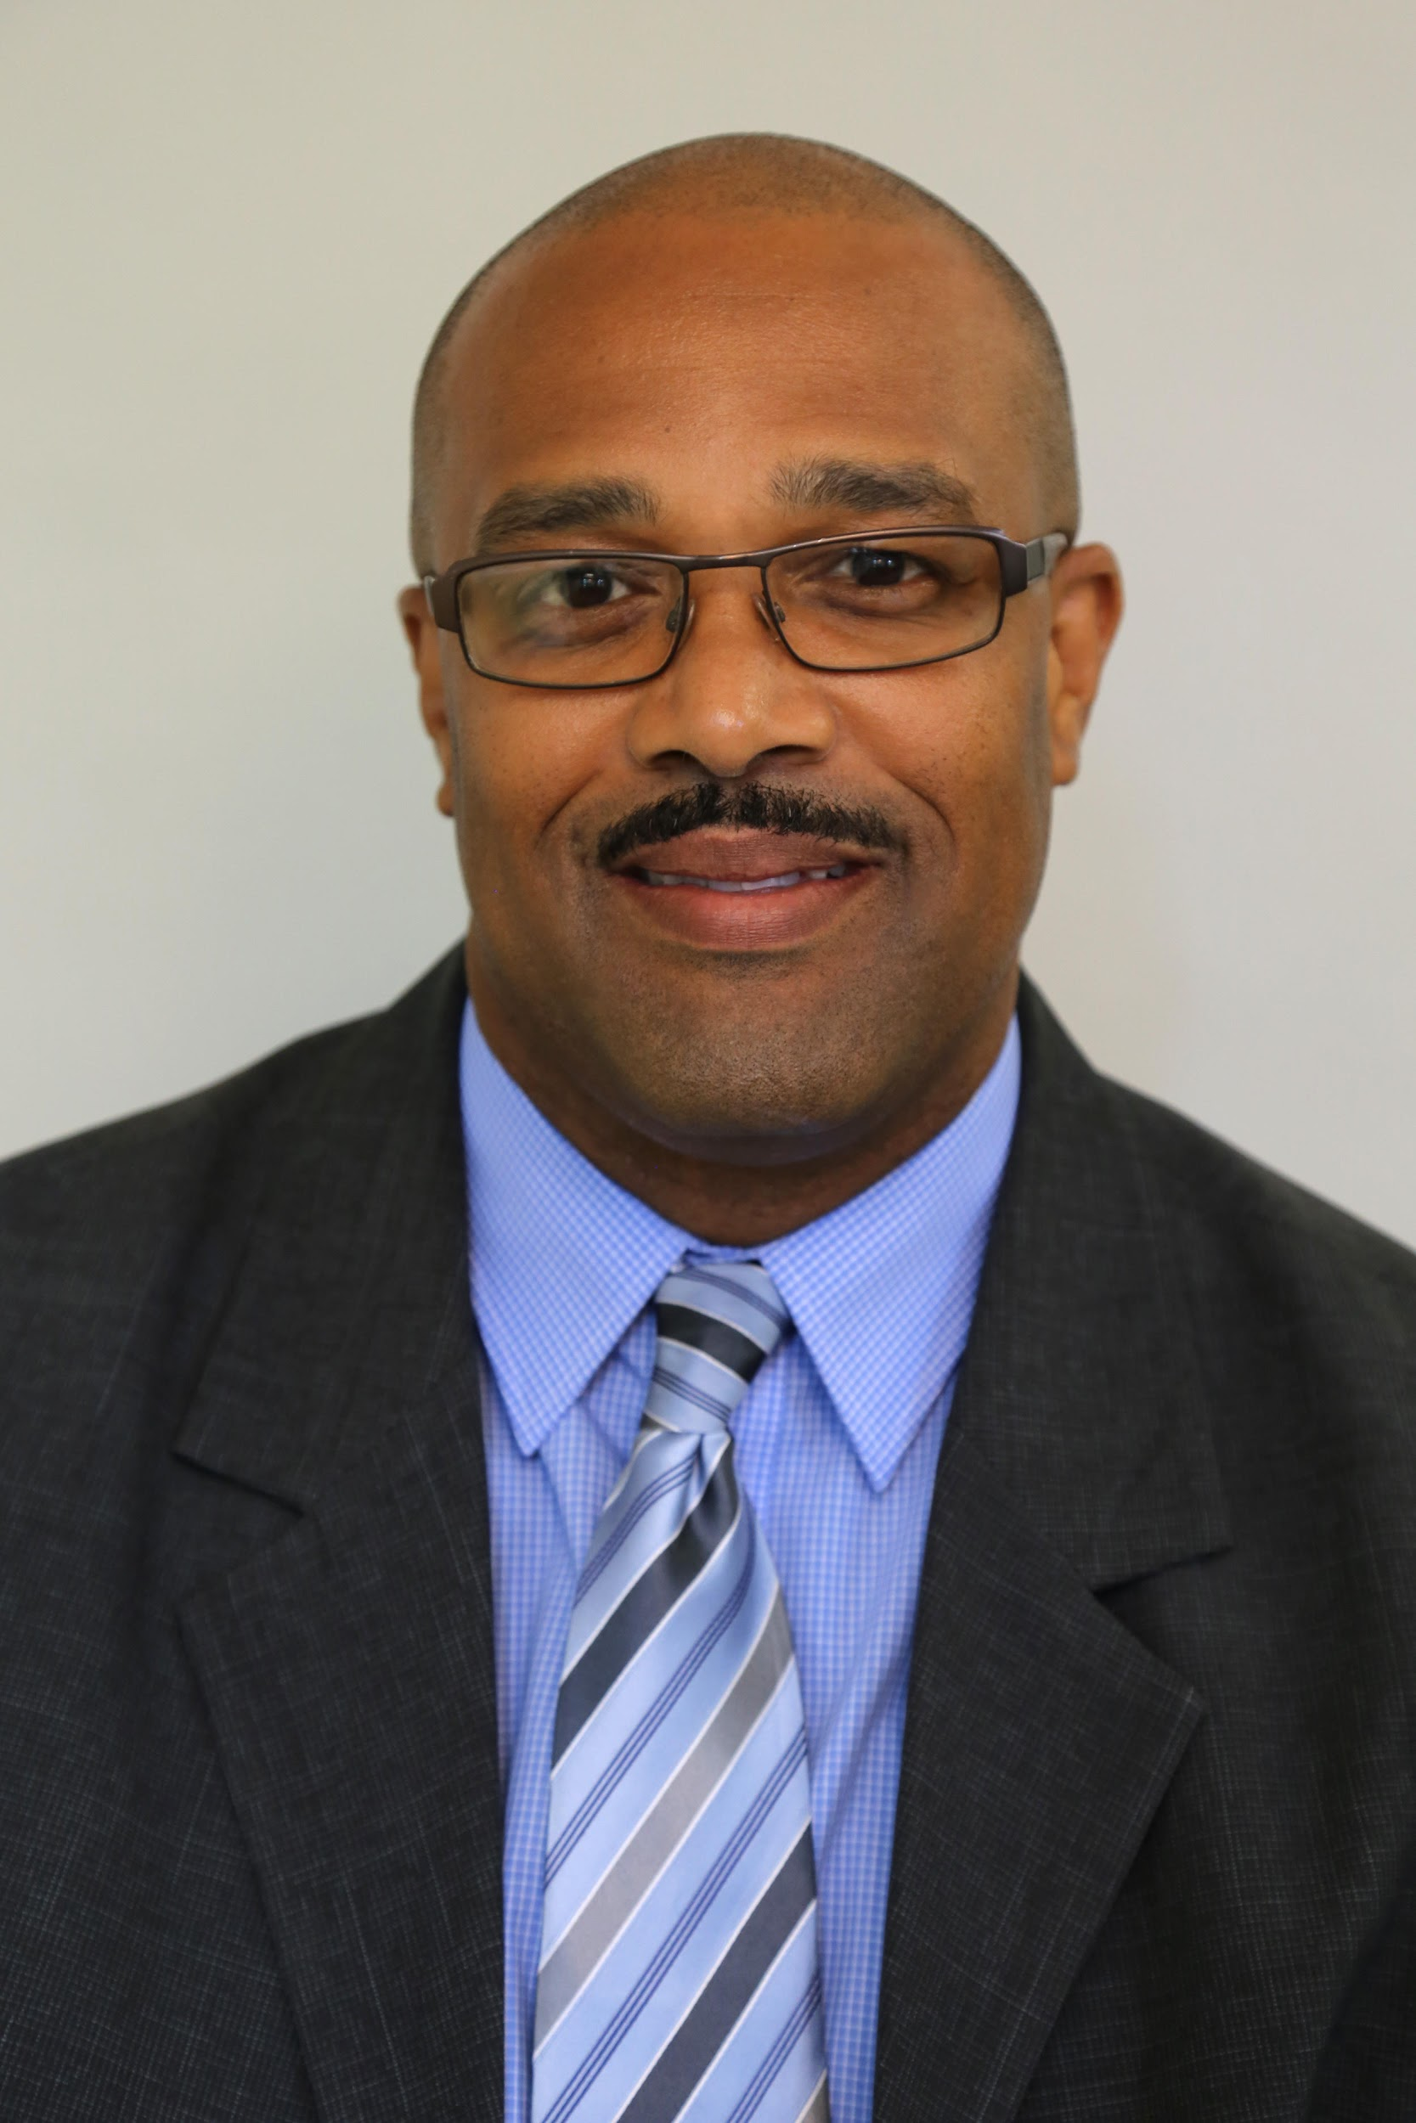Lavelle mohammed

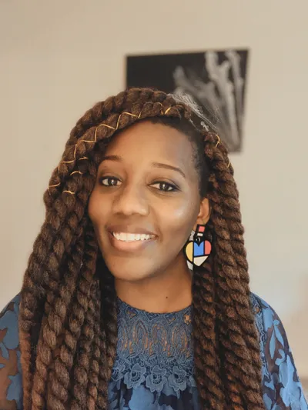Winnie Okello

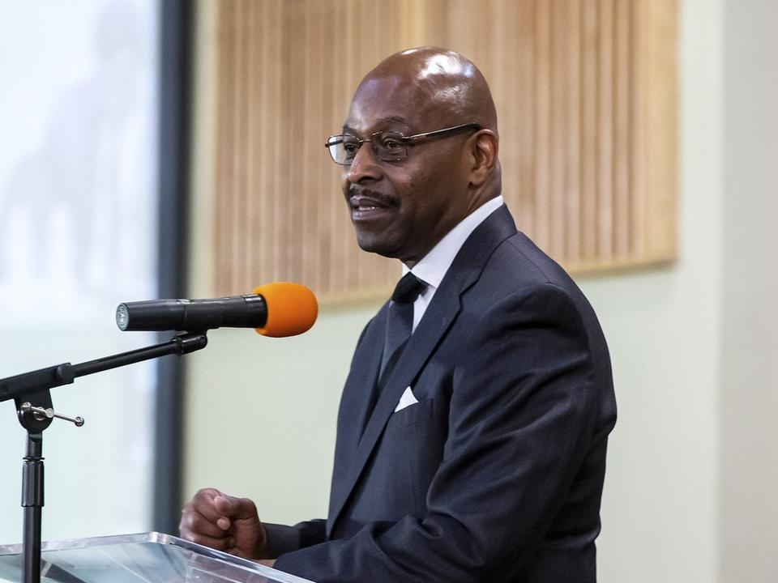Reverend Earl Harris

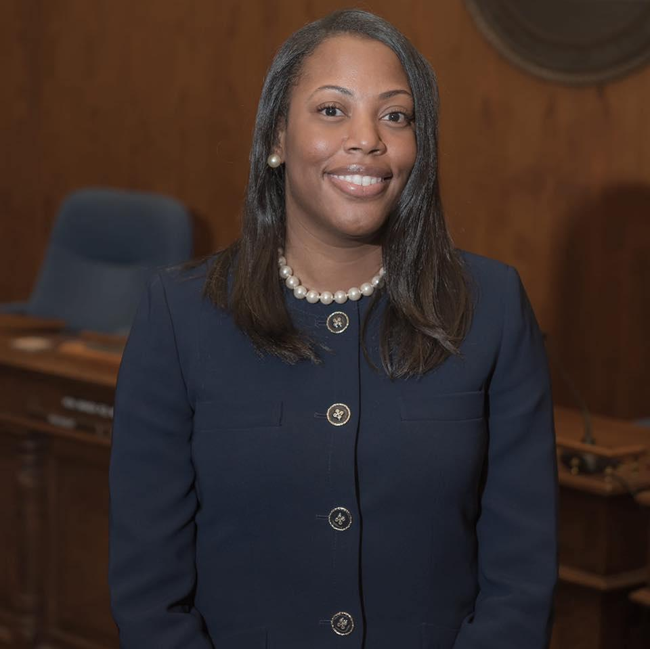Danielle Bowers

Floyd Stokes

**Purim: [title to be determined] (Leslie create flyer)**

Date: February 25th

Celebrate silliness this Purim with Beth El! We will read Megillah together with Chisuk Emuna on Zoom at 6:30pm. Between chapters we will hold a costume contest by age: babies through 5th graders, 6th grade through 12th, and adults, so everyone bring your best costume game to zoom! Between chapters we will also hear short presentations about opportunities to give *matanot l’evyonim* charitable gifts to the poor. When Megillah reading is over the fun continues with a special Purim Spiel created by Beth El’s own Tony-award winning musician Stuart Malina and Rabbi Capptauber!

The festivities continue on Friday February 26th, with the opportunity to pick up a celebratory Purim Seudah meal by our own Paul Schmanske. Email [patty@bethelhbg.org](mailto:patty@bethelhbg.org) or call Beth El 717 232-0556 to order a meal.

Cost: $20.00 per meal

Pick-up times 3:30 - 5:00 pm

Do we want to add a picture?

### Monthly:

**Learning Torah (and ourselves) through Art (Bronwen will create flyer)**

**Note for flyer: I love this kind of abstract watercolor background like in the book cover at** [**this link**](https://www.google.com/url?sa=i&url=https%3A%2F%2Fwww.amazon.com%2FArt-Gathering-How-Meet-Matters%2Fdp%2F1594634920&psig=AOvVaw1Fzy1CrZijPzLwNopiF57g&ust=1607620940647000&source=images&cd=vfe&ved=0CAIQjRxqFwoTCLDu5uq0we0CFQAAAAAdAAAAABAF)**, if you could do a background like that?**

Dates: January 21st, February 18th, March 18th, April 22nd, May 20th

Time: 7pm-9pm

Want to dive deeper, beyond the surface of the Torah? Want to tap into your creative potential? Want to learn more about yourself and your spirituality? Now is your chance! Join Rabbi Ariana Capptauber and Rabbi Bronwen Mullin for a workshop in which we will create art that springs forth from the Torah and is, itself, new torah. We will be working in the tradition of the rabbis who used their imaginations to expand the narrative of the bible. As Rabbi Mullin says, “Our rabbis for years have attempted to take archetypal [biblical] stories and read their own experiences into them. The more we delve into that, the more we find actual reflections of ourselves.”

In this monthly workshop, we will create our own *midrash*, our own exegesis through our art, using as our guides biblical stories, rabbinic commentaries, and our own creative skills.

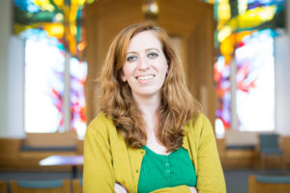

Rabbi Bronwen Mullin, a playwright, composer, multi-instrumentalist and educator has served as rabbinic artist-in-residence at the Jewish Theological Seminary and is currently the Rabbi of B’nai Jacob in Jersey City. Rabbi Mullin is also the co-founder of Meta-Phys Ed, a multidisciplinary performance group wrestling with religious texts. Judaism is Rabbi Mullin’s favorite art form, and she feels humbled to practice in this sacred craft.

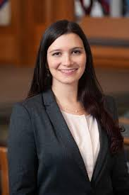

Rabbi Ariana Capptauber is currently the rabbi at Beth El Temple in Harrisburg. At Tufts University Rabbi Capptauber studied English literature and completed a senior honors thesis in Creative Writing. She also won Tufts’ Morton N. Cohen prize in a short fiction contest. At the Jewish Theological Seminary Rabbi Capptauber began using her creative writing skills as a lens through which to view Torah, and her senior thesis was a creative re-telling of Jacob’s flight from home.

**A little night music (continuation) (Leslie Update flyer)**

New Dates: January 14th, February 17th, March 25th, April 15th

**Beth El Parents of young kids group (continuation) (Leslie Update flyer)**

New Dates: January 7th, February 4th, March 4th

**Pajama Havdalah (continuation) (Leslie Update flyer)**

On January 9th Beth El will have a special storytelling Havdalah together with PJ Library

On February 20th we will have a special musical Pajama Havdalah with Camp Ramah!

**Women’s Rosh Hodesh Group ( Patty create flyer)**

Dates: Sunday mornings of Rosh Hodesh at 10am January 17th, February 14th, March 14th

*Debra Kaunitz is going to write something up

### Classes:

**Great Debates (continuation) (Patty Update flyer)**

Dates: Weekly on Wednesdays at 11am from January 6th through February 17th

**Leadership in a time of crisis (continuation) (Patty Update flyer)**

Dates: Tuesday evenings at 7:30pm, January 12th, 19th